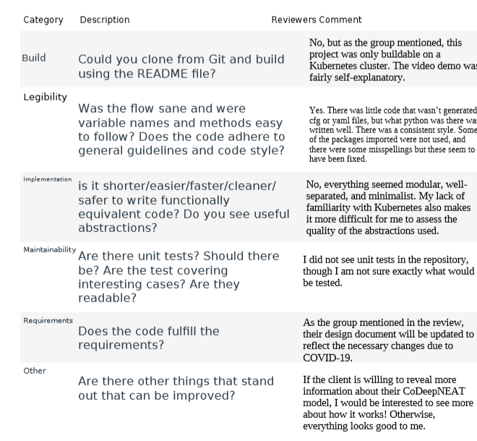

|  |  |
| --- | --- |
| Category | Action Taken by Reviewed Group |
| Build | No action taken. |
| Legibility | We have gone through the code and removed unused libraries. |
| Implementation | No action taken. |
| Maintainability | No action taken, it is difficult to make a time effective test that would be representative of our code base. |
| Requirements | We have updated our design document. |
| Other | No action taken. Unfortunately we cannot divulge more about the Neat algorithm. |